**Western United States**

Presentation made by

Vira Lytvyn

**Lviv 2011**

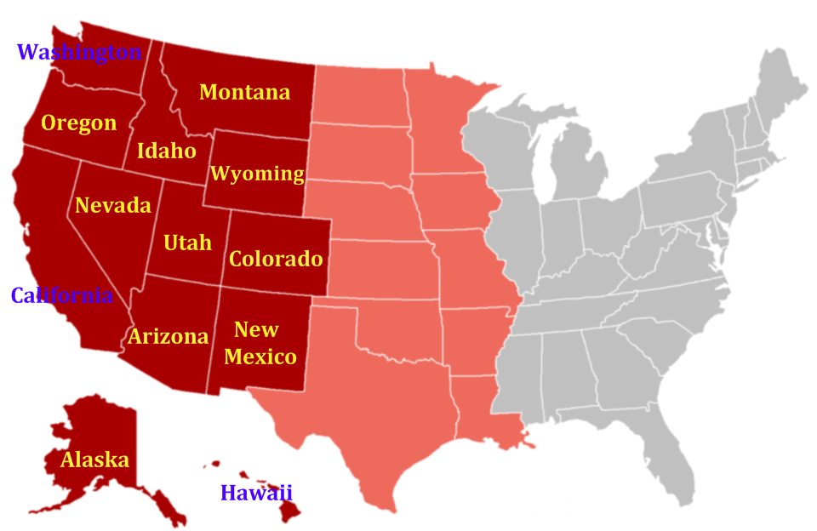As defined by the [Census Bureau](http://en.wikipedia.org/wiki/United_States_Census_Bureau), the western United States includes 13 states:  [Alaska](http://en.wikipedia.org/wiki/Alaska), [Arizona](http://en.wikipedia.org/wiki/Arizona), [California](http://en.wikipedia.org/wiki/California), [Colorado](http://en.wikipedia.org/wiki/Colorado),[Hawaii](http://en.wikipedia.org/wiki/Hawaii), [Idaho](http://en.wikipedia.org/wiki/Idaho), [Montana](http://en.wikipedia.org/wiki/Montana), [Nevada](http://en.wikipedia.org/wiki/Nevada), [New Mexico](http://en.wikipedia.org/wiki/New_Mexico), [Oregon](http://en.wikipedia.org/wiki/Oregon), [Utah](http://en.wikipedia.org/wiki/Utah), [Washington](http://en.wikipedia.org/wiki/Washington_(U.S._state)) and [Wyoming](http://en.wikipedia.org/wiki/Wyoming).

In turn, this region is sub-divided into Mountain and Pacific areas.

**The Mountain States:** [Montana](http://en.wikipedia.org/wiki/Montana), [Wyoming](http://en.wikipedia.org/wiki/Wyoming), [Colorado](http://en.wikipedia.org/wiki/Colorado), [New Mexico](http://en.wikipedia.org/wiki/New_Mexico), [Idaho](http://en.wikipedia.org/wiki/Idaho), [Utah](http://en.wikipedia.org/wiki/Utah), [Arizona](http://en.wikipedia.org/wiki/Arizona), and [Nevada](http://en.wikipedia.org/wiki/Nevada)

**The Pacific States :**  [Washington](http://en.wikipedia.org/wiki/Washington_(U.S._state)),  [Oregon](http://en.wikipedia.org/wiki/Oregon),  [California](http://en.wikipedia.org/wiki/California), [Alaska](http://en.wikipedia.org/wiki/Alaska)  and  [Hawaii](http://en.wikipedia.org/wiki/Hawaii).

The West is still one of the most sparsely settled areas in the United States. The entire Western region has also been strongly influenced by [European](http://en.wikipedia.org/wiki/Culture_of_Europe), [Hispanic](http://en.wikipedia.org/wiki/Hispanic_and_Latino_Americans), [Asian](http://en.wikipedia.org/wiki/Asian_Americans), and [Native Americans](http://en.wikipedia.org/wiki/Native_Americans_in_the_United_States); it contains the largest number of minorities in the U.S. and encompasses the only four American states where all racial groups including [Caucasians](http://en.wikipedia.org/wiki/Caucasian_race) are a minority (California, Hawaii, New Mexico, and Texas).

The West has been shaped by a variety of ethnic groups. [Hawaii](http://en.wikipedia.org/wiki/Hawaii) is the only state in the union in which [Asian Americans](http://en.wikipedia.org/wiki/Asian_American) outnumber white American residents. Asians from many countries have settled in [California](http://en.wikipedia.org/wiki/California) and other coastal states in several waves of immigration since the 19th century, contributing to the [Gold Rush](http://en.wikipedia.org/wiki/Gold_Rush), the building of the transcontinental railroad, agriculture, and more recently, high technology.

The state of [Utah](http://en.wikipedia.org/wiki/Utah) has a [Mormon](http://en.wikipedia.org/wiki/Mormon) majority (estimated 65-75% of the state's population), while some cities like [Albuquerque, New Mexico](http://en.wikipedia.org/wiki/Albuquerque,_New_Mexico), [Spokane, Washington](http://en.wikipedia.org/wiki/Spokane,_Washington) and [Tucson, Arizona](http://en.wikipedia.org/wiki/Tucson,_Arizona) faces [Indian Reservations](http://en.wikipedia.org/wiki/Indian_Reservation) of Native American tribes, and there are [Alaskan Natives](http://en.wikipedia.org/wiki/Alaskan_Natives) and [Native Hawaiians](http://en.wikipedia.org/wiki/Native_Hawaiians) to bring forth a great deal of racial diversity.

The largest concentrations for black Americans in the West can be found in Los Angeles, Oakland, Sacramento, San Francisco, Las Vegas, Denver, Colorado Springs and parts of Arizona.

The Western United States has more males than females, than any other region in the United States.

The West has several long rivers that empty into the [Pacific Ocean](http://en.wikipedia.org/wiki/Pacific_Ocean), while the eastern rivers run into the [Gulf of Mexico](http://en.wikipedia.org/wiki/Gulf_of_Mexico). According to the [United States Coast Guard](http://en.wikipedia.org/wiki/United_States_Coast_Guard), "The Western Rivers System consists of the  [Mississippi](http://en.wikipedia.org/wiki/Mississippi_River), [Ohio](http://en.wikipedia.org/wiki/Ohio_River),  [Missouri](http://en.wikipedia.org/wiki/Missouri_River), [Illinois](http://en.wikipedia.org/wiki/Illinois_River),  [Tennessee](http://en.wikipedia.org/wiki/Tennessee_River), [Cumberland](http://en.wikipedia.org/wiki/Cumberland_River), [Arkansas](http://en.wikipedia.org/wiki/Arkansas_River) and [White Rivers](http://en.wikipedia.org/wiki/White_River_(Arkansas)) and their tributaries, and certain other rivers that flow towards the [Gulf of Mexico](http://en.wikipedia.org/wiki/Gulf_of_Mexico)."

As a very gross [generalization](http://en.wikipedia.org/wiki/Generalization), the climate of the West can be described as overall [semiarid](http://en.wikipedia.org/wiki/Semiarid); however, parts of the West get extremely high amounts of rain and/or snow, and still other parts are true desert and get less than 10 inches of rain per year. Also, the climate of the West is quite unstable, and areas that are normally wet can be very dry for years and vice versa.

The movies replaced the dime novel as the chief entertainment source featuring western fiction, later the community of [Hollywood, Los Angeles](http://en.wikipedia.org/wiki/Hollywood,_Los_Angeles) became the headquarters of the [mass media](http://en.wikipedia.org/wiki/Mass_media) such as [radio](http://en.wikipedia.org/wiki/Radio) and [television](http://en.wikipedia.org/wiki/Television) production.

The West is reach in [copper](http://en.wikipedia.org/wiki/Copper), [gold](http://en.wikipedia.org/wiki/Gold), [lead](http://en.wikipedia.org/wiki/Lead), [molybdenum](http://en.wikipedia.org/wiki/Molybdenum), [silver](http://en.wikipedia.org/wiki/Silver), [tungsten](http://en.wikipedia.org/wiki/Tungsten), [zinc](http://en.wikipedia.org/wiki/Zinc). The Wyoming Basin and several smaller areas contain significant reserves of [coal](http://en.wikipedia.org/wiki/Coal), [natural gas](http://en.wikipedia.org/wiki/Natural_gas), [oil shale](http://en.wikipedia.org/wiki/Oil_shale), and [petroleum](http://en.wikipedia.org/wiki/Petroleum). The [Coeur d'Alene](http://en.wikipedia.org/wiki/Coeur_d%27Alene,_Idaho) mine of northern Idaho produces silver, lead, and zinc.

There are major [nuclear power](http://en.wikipedia.org/wiki/Nuclear_power) plants, but also several cities such as Oakland, [Berkeley](http://en.wikipedia.org/wiki/Berkeley,_California) and [Davis](http://en.wikipedia.org/wiki/Davis,_California) have declared themselves as [nuclear-free zones](http://en.wikipedia.org/wiki/Nuclear-free_zone).

Agriculture and forestry are important industries. Agriculture includes dry land and irrigated farming and [livestock](http://en.wikipedia.org/wiki/Livestock) grazing.

The transport system is very developed.

Three more metro areas of  [Denver](http://en.wikipedia.org/wiki/Denver),  [Phoenix](http://en.wikipedia.org/wiki/Phoenix,_Arizona)  and  [Seattle](http://en.wikipedia.org/wiki/Seattle) have over a million residents, while the three fastest growing metro areas were [Salt Lake City](http://en.wikipedia.org/wiki/Salt_Lake_City), [Las Vegas, Nevada](http://en.wikipedia.org/wiki/Las_Vegas,_Nevada) and [Portland, Oregon](http://en.wikipedia.org/wiki/Portland,_Oregon).

**Major Metropolitan Areas**

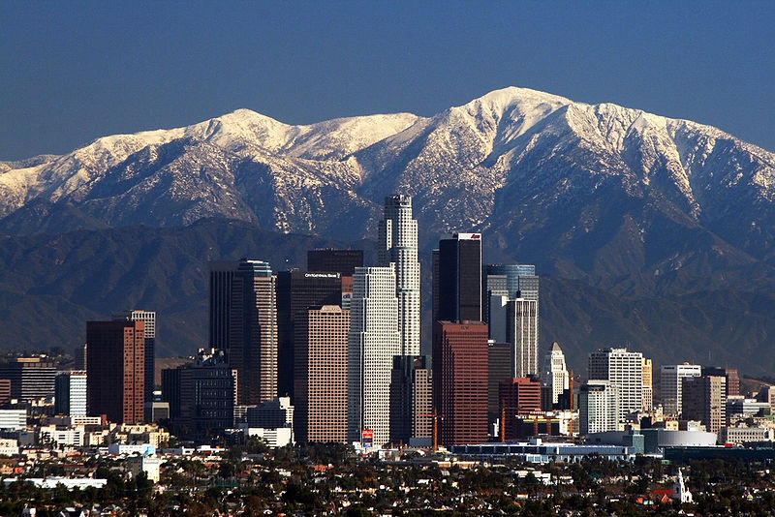

[Los Angeles](http://en.wikipedia.org/wiki/Los_Angeles)-[Long Beach](http://en.wikipedia.org/wiki/Long_Beach,_California)-[Santa Ana](http://en.wikipedia.org/wiki/Santa_Ana,_California) [MSA](http://en.wikipedia.org/wiki/Los_Angeles_metropolitan_area), [California](http://en.wikipedia.org/wiki/California)

[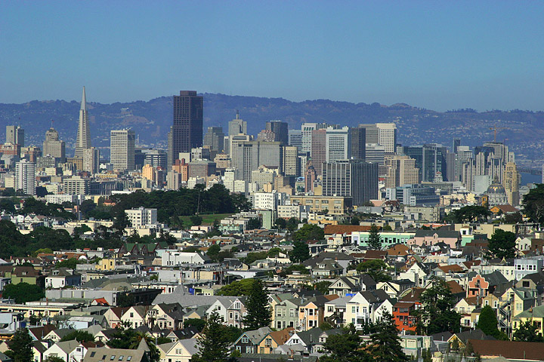](http://upload.wikimedia.org/wikipedia/commons/5/57/Lightmatter_sanfrancisco.jpg)

[San Francisco](http://en.wikipedia.org/wiki/San_Francisco)-[Oakland](http://en.wikipedia.org/wiki/Oakland,_California)-[San Jose](http://en.wikipedia.org/wiki/San_Jose,_California) [MSA](http://en.wikipedia.org/wiki/San_Francisco_Bay_Area), [California](http://en.wikipedia.org/wiki/California)

[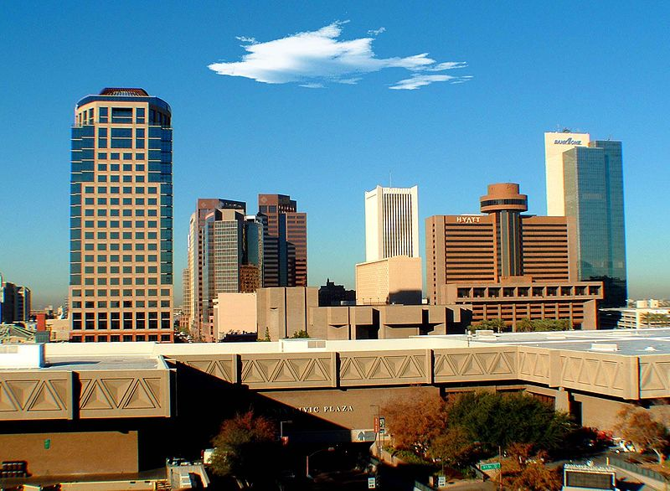](http://upload.wikimedia.org/wikipedia/commons/6/62/Phoenix_skyline_Arizona_USA.jpg)

[Phoenix](http://en.wikipedia.org/wiki/Phoenix,_Arizona)-[Mesa](http://en.wikipedia.org/wiki/Mesa,_Arizona)-[Scottsdale](http://en.wikipedia.org/wiki/Scottsdale,_Arizona)-[Glendale](http://en.wikipedia.org/wiki/Glendale,_Arizona)[MSA](http://en.wikipedia.org/wiki/Phoenix_metropolitan_area), [Arizona](http://en.wikipedia.org/wiki/Arizona)

[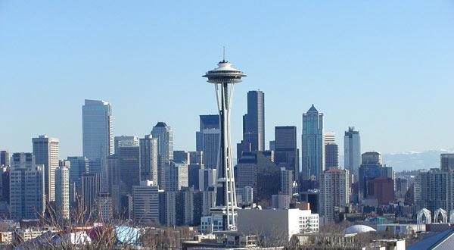](http://upload.wikimedia.org/wikipedia/commons/c/c2/Seattleskyline1cropped.JPG)

[Seattle](http://en.wikipedia.org/wiki/Seattle)-[Tacoma](http://en.wikipedia.org/wiki/Tacoma,_Washington)-[Bellevue](http://en.wikipedia.org/wiki/Bellevue,_Washington) [MSA](http://en.wikipedia.org/wiki/Seattle_metropolitan_area), [Washington](http://en.wikipedia.org/wiki/Washington_(U.S._state))

[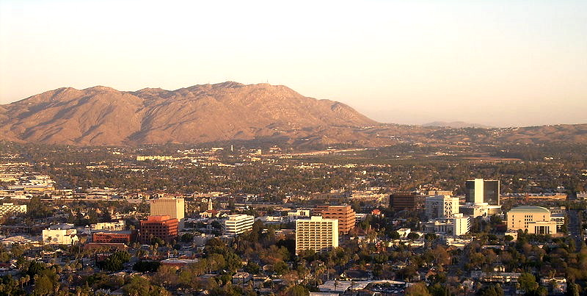](http://upload.wikimedia.org/wikipedia/commons/1/18/Riverside_06Skyline.JPG)

[Riverside](http://en.wikipedia.org/wiki/Riverside,_California)-[San Bernardino](http://en.wikipedia.org/wiki/San_Bernardino,_California)-[Ontario](http://en.wikipedia.org/wiki/Ontario,_California)[MSA](http://en.wikipedia.org/wiki/Inland_Empire_(California)), [California](http://en.wikipedia.org/wiki/California)

**Tourism**

Every year the scenic areas and recreational opportunities draw millions of tourists.

People from all over the world visit the sites to hike, camp, or engage in mountain sports.

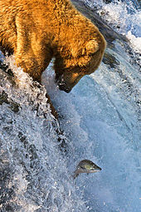Every state in the USA has some world famous sites sing. Many people know these places, but do not imagine what state they situated in.

**Alaska**

[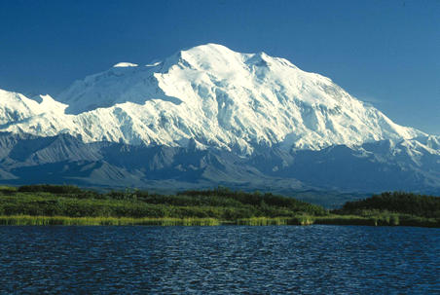](http://upload.wikimedia.org/wikipedia/commons/8/8b/Denali_Mt_McKinley.jpg)[Grizzly bear](http://en.wikipedia.org/wiki/Grizzly_bear) fishing for [salmon](http://en.wikipedia.org/wiki/Salmon)at [Brooks Falls](http://en.wikipedia.org/wiki/Katmai_National_Park_and_Preserve).

[Mount McKinley](http://en.wikipedia.org/wiki/Mount_McKinley) is both the highest peak in Alaska and in all of North America.

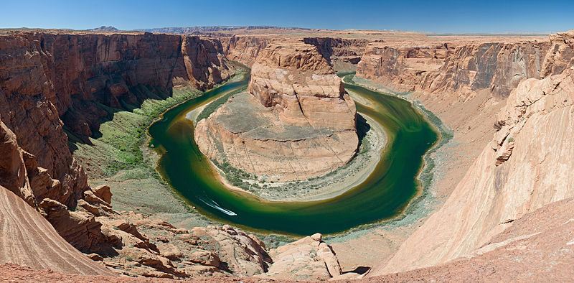

**Arizona**

The Horseshoe Bend of the [Colorado River](http://en.wikipedia.org/wiki/Colorado_River)

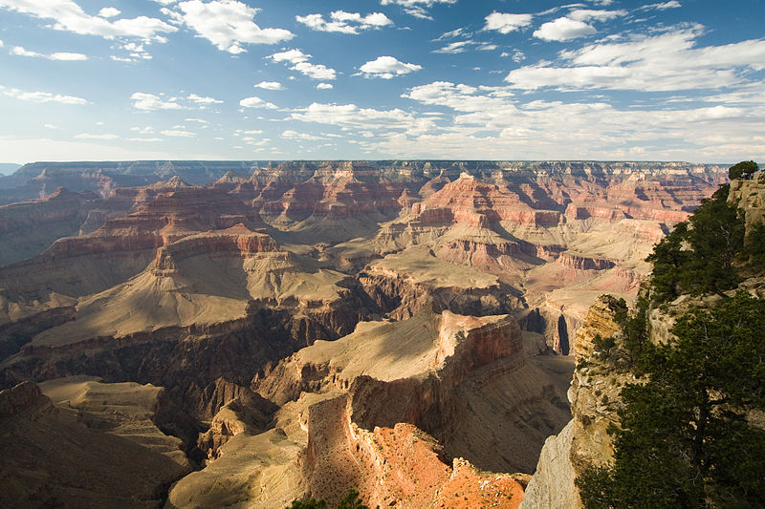

[Grand Canyon](http://en.wikipedia.org/wiki/Grand_Canyon)

**[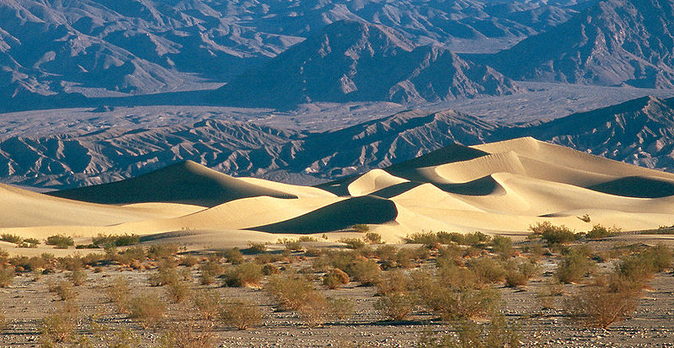](http://upload.wikimedia.org/wikipedia/commons/6/62/Death_Valley_Mesquite_Sand_Dunes.jpg)California**

[Death Valley](http://en.wikipedia.org/wiki/Death_Valley)

[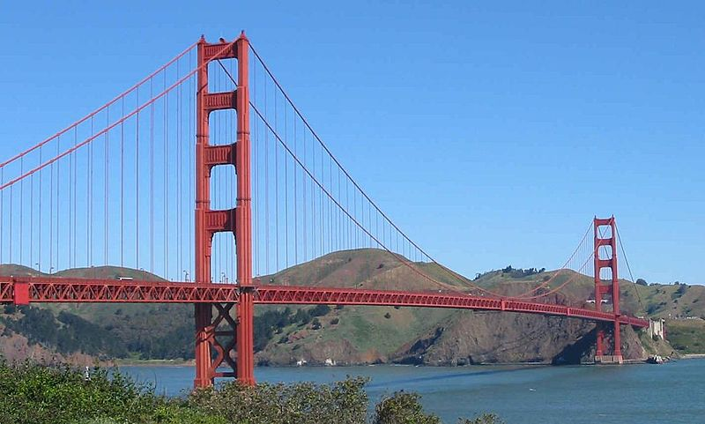](http://upload.wikimedia.org/wikipedia/commons/3/3e/GoldenGateBridge.jpg)

The [Golden Gate Bridge](http://en.wikipedia.org/wiki/Golden_Gate_Bridge) in [San Francisco](http://en.wikipedia.org/wiki/San_Francisco), one of California's most famous landmarks.

[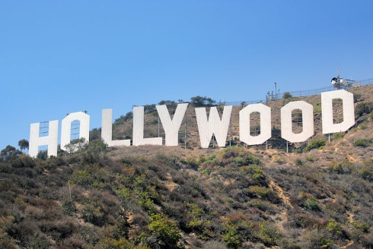](http://upload.wikimedia.org/wikipedia/commons/c/ce/HollywoodSign.jpg)

Hollywood film studios

[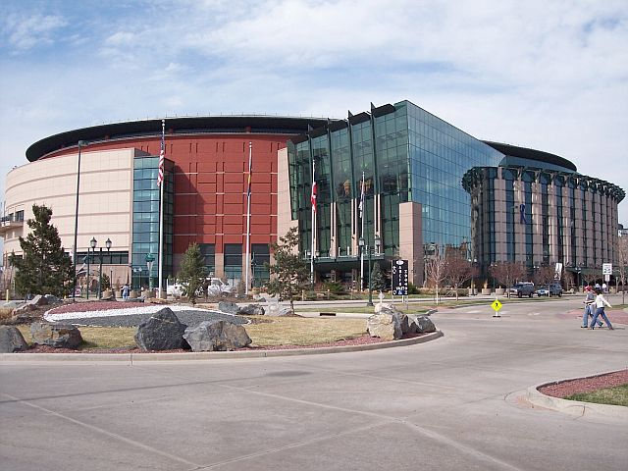](http://upload.wikimedia.org/wikipedia/commons/c/c0/Pepsi_Center.jpg) **Colorado**

[Pepsi Center](http://en.wikipedia.org/wiki/Pepsi_Center) in Denver, home of the [Denver Nuggets](http://en.wikipedia.org/wiki/Denver_Nuggets) [National Basketball Association](http://en.wikipedia.org/wiki/National_Basketball_Association) club, the [Colorado Avalanche](http://en.wikipedia.org/wiki/Colorado_Avalanche) [National Hockey League](http://en.wikipedia.org/wiki/National_Hockey_League) club, and the [Colorado Mammoth](http://en.wikipedia.org/wiki/Colorado_Mammoth) [National Lacrosse League](http://en.wikipedia.org/wiki/National_Lacrosse_League) club.

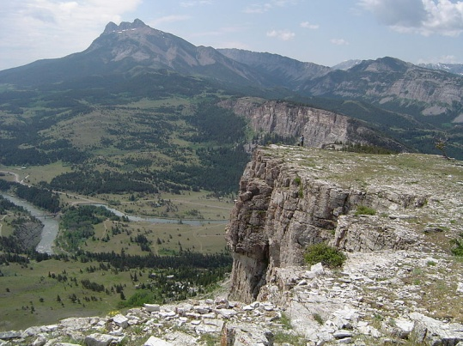

**Montana**

The headwaters of the [Sun River](http://en.wikipedia.org/wiki/Sun_River), just below [Gibson Reservoir](http://en.wikipedia.org/wiki/Gibson_Reservoir)

**[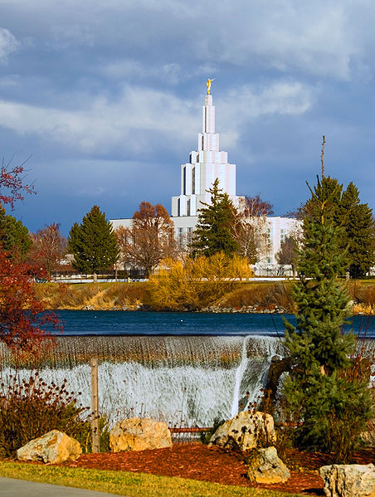](http://upload.wikimedia.org/wikipedia/commons/b/bc/Idaho_Falls_Temple.jpg) Idaho**

The Church of Jesus Christ of Latter-day Saints Idaho Falls Temple.

American Falls Dam

[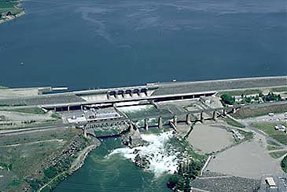](http://upload.wikimedia.org/wikipedia/commons/9/9e/US_ID_AmericanFalls.jpg)

**[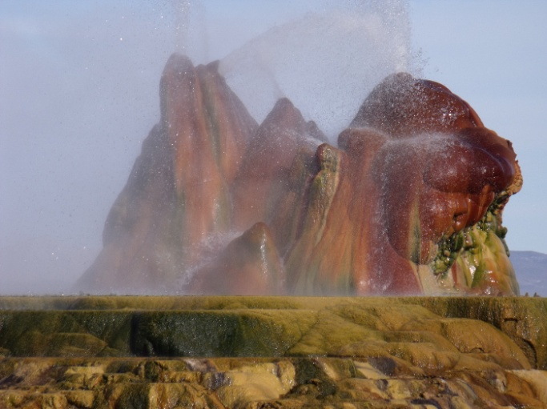](http://upload.wikimedia.org/wikipedia/commons/2/23/Fly_geyser_in_nevada.jpg) Nevada**

[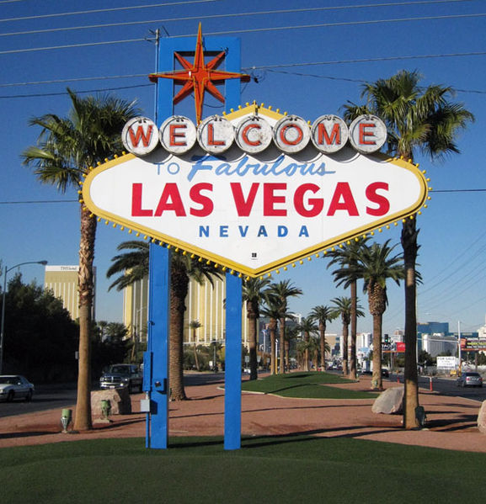](http://upload.wikimedia.org/wikipedia/commons/1/1d/Welcome_to_fabulous_las_vegas_sign.jpg) [Fly Geyser](http://en.wikipedia.org/wiki/Fly_Geyser)

Gambling erupted once more following a recession in the early 20th century, helping to build the city of Las Vegas

**New Mexico**

[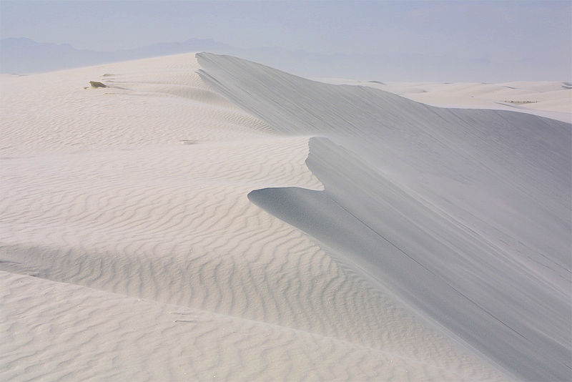](http://upload.wikimedia.org/wikipedia/en/b/bb/White_sands_national_monument_dune.jpg)[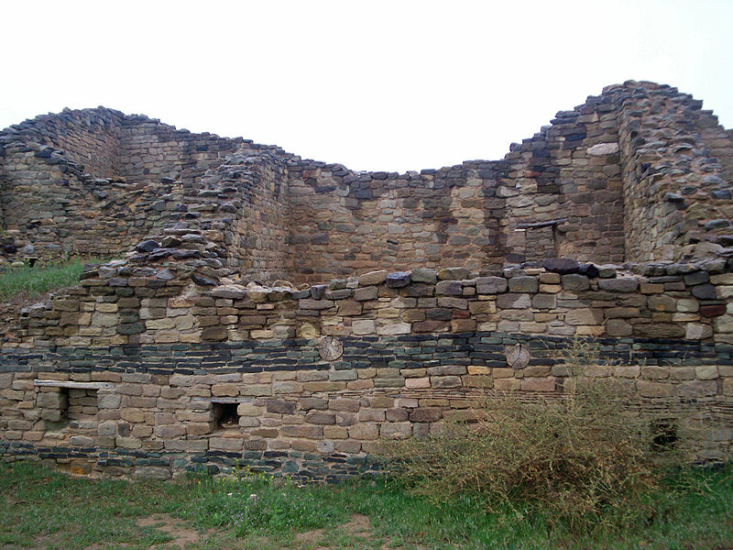](http://upload.wikimedia.org/wikipedia/commons/8/80/Aztecruinsnm.jpg)

[Aztec Ruins National Monument](http://en.wikipedia.org/wiki/Aztec_Ruins_National_Monument)

[White Sands National Monument](http://en.wikipedia.org/wiki/White_Sands_National_Monument)

**[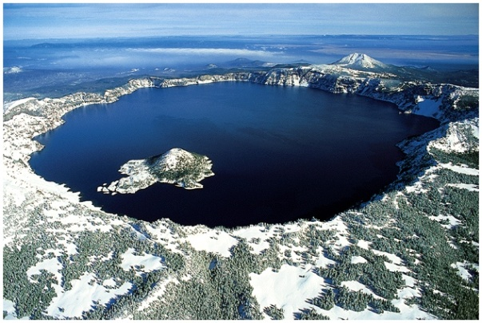](http://upload.wikimedia.org/wikipedia/commons/b/b5/Crater_lake_oregon.jpg)[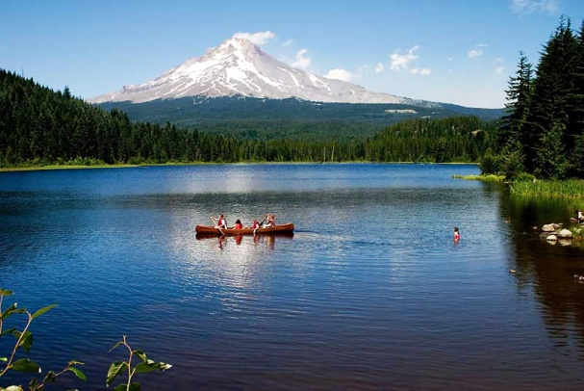](http://upload.wikimedia.org/wikipedia/commons/4/44/Trilliumlake.jpg) Oregon**

[Mount Hood](http://en.wikipedia.org/wiki/Mount_Hood), with [Trillium Lake](http://en.wikipedia.org/wiki/Trillium_Lake)  An aerial view of [Crater Lake](http://en.wikipedia.org/wiki/Crater_Lake) in

in the foreground Oregon

**Utah Washington**

[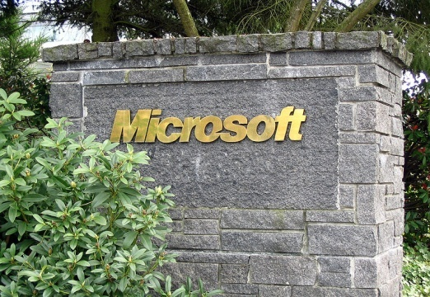](http://upload.wikimedia.org/wikipedia/commons/2/27/Microsoft_sign_closeup.jpg)[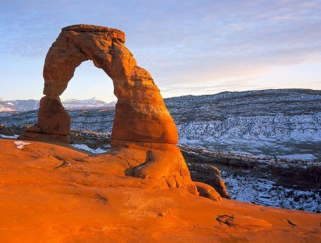](http://upload.wikimedia.org/wikipedia/commons/0/06/Delicatearch1.jpg) Delicate Arch, [Arches National Park](http://en.wikipedia.org/wiki/Arches_National_Park), Utah

[Microsoft](http://en.wikipedia.org/wiki/Microsoft) Corporation headquarters in [Redmond](http://en.wikipedia.org/wiki/Redmond,_Washington), an [Eastside](http://en.wikipedia.org/wiki/Eastside_(King_County,_Washington)) suburb of Seattle.

**Wyoming**

[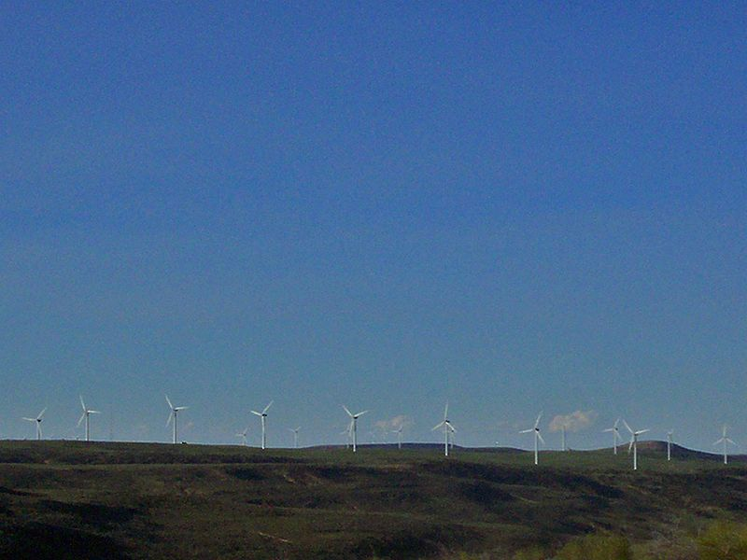](http://upload.wikimedia.org/wikipedia/commons/1/17/Wyomingwindfarm.jpg)[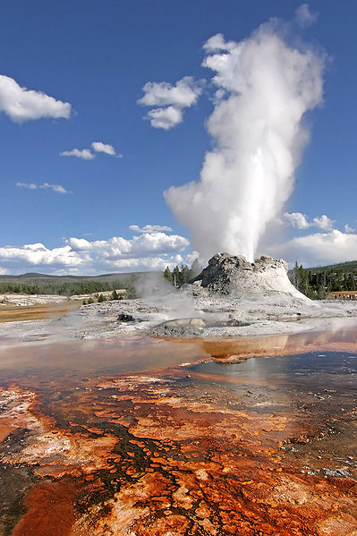](http://upload.wikimedia.org/wikipedia/commons/4/47/Yellowstone_Castle_Geysir_Edit.jpg)An eruption of Castle Geyser in [Yellowstone National Park](http://en.wikipedia.org/wiki/Yellowstone_National_Park)

Electricity generating [wind farm](http://en.wikipedia.org/wiki/Wind_farm) in [Uinta County](http://en.wikipedia.org/wiki/Uinta_County).

[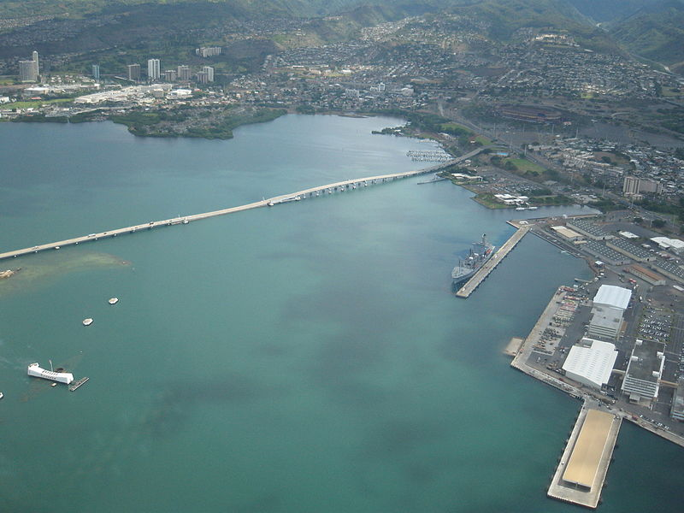](http://upload.wikimedia.org/wikipedia/en/7/74/USSArizona_Bridge_Bowfin_Stadium.jpg)

**Hawaii**

Part of [Pearl Harbor](http://en.wikipedia.org/wiki/Pearl_Harbor), with [Aloha Stadium](http://en.wikipedia.org/wiki/Aloha_Stadium), the [USS *Arizona*](http://en.wikipedia.org/wiki/USS_Arizona_Memorial),  [USS  *Bowfin*](http://en.wikipedia.org/wiki/USS_Bowfin_(SS-287)) (submarine), museums,[Admiral Clarey Bridge](http://en.wikipedia.org/wiki/Admiral_Clarey_Bridge), and naval yards visible.

The West has a continuing reputation for being open-minded and for being one of the most racially progressive areas in the United States.